Speculation or Fundamentals?  
 Behind the Valuation of Crypto-Tokens

- By Marco Di Maggio, Cesare Fracassi, and Sam Shoar -

# **TLDR**

# **Some crypto-tokens, which represent control stakes in the underlying protocols, share similarities with traditional public company shares, including the ability to generate income.** Therefore, they can be analyzed using conventional valuation methods such as the price-to-earnings (P/E) ratio or discounted cash flow (DCF) analysis.

# **The valuation of crypto-token markets aligns closely with the broader small-cap technology sector.** On average, crypto-tokens have a trailing P/E ratio of 27.3, while small-cap tech companies maintain a P/E ratio of 29.5.

# **On average, the valuation of crypto-tokens tends to reflect their underlying fundamentals.** When utilizing a DCF model with reasonable assumptions concerning profit margins, risk factors, and growth rates, the resulting valuations closely mirror the observed market values within crypto-token markets.

Many regulators and traditional financial commentators have voiced their criticisms regarding cryptocurrencies, contending that these digital assets lack any inherent fundamental value. Some experts argue that, in contrast to traditional financial securities, cryptocurrencies do not offer dividends or coupons, and unlike physical commodities, they are not utilized in production processes. For instance, the International Monetary Fund (IMF) has [suggested](https://www.imf.org/en/Publications/fandd/issues/2022/09/Point-of-View-the-superficial-allure-of-crypto-Hilary-Allen) that “at a more fundamental level, the value of crypto assets is driven entirely by demand because there is no productive capacity behind them, and so founders and early investors can profit only if they can find new investors to sell to.” Bank of England Governor Andrew Bailey has also reinforced this perspective, [asserting](https://fortune.com/2022/06/13/bank-of-england-chief-says-crypto-has-no-intrinsic-value-following-collapse/) that cryptocurrencies possess "no intrinsic value." Consequently, this narrative has led some to believe that the crypto markets are primarily driven by speculative activities, bubbles, gambling, front-running, Ponzi and pump-and-dump schemes. However, is it accurate to claim that all digital assets lack any fundamental value?

First and foremost, it's essential to recognize that not all cryptocurrencies are cut from the same cloth. Broadly speaking, digital assets can be categorized into two primary groups within the blockchain technology landscape:

*(i) Cryptocurrencies:* This category encompasses foundational digital assets such as Bitcoin, Ethereum, Avalanche, Solana, and Polkadot. These assets serve as the infrastructure layer, providing a decentralized consensus mechanism and a smart contract environment.

*(ii) Crypto-tokens:* In contrast, crypto-tokens represent the application layer, where developers and decentralized autonomous organizations (DAOs) deploy smart contracts to offer various financial and commercial services. These services include trading, borrowing and lending, as well as the creation of non-fungible tokens (NFTs).

Among these two groups, crypto-tokens bear the closest resemblance to shares of public companies. They essentially represent control claims on the residual cash flows generated by the underlying platforms. For instance, consider Aave, a decentralized bilateral marketplace platform built on the Ethereum blockchain. Aave enables users to lend and borrow cryptocurrencies among themselves, with borrowers paying a variable interest rate received by the lender. Notably, Aave's treasury collects a small fraction of borrowed amount as origination fees, and the governance of these fees is determined by Aave's token holders through DAO voting. Similarly, Uniswap, recognized as the largest DeFi (Decentralized Finance) protocol, is contemplating the activation of a fee switch. This change would introduce a small commission on all swap fees. Because these protocols generate income, they can be assessed using traditional valuation techniques, including relative valuation and discounted cash flow (DCF) methods.

The emergence of income-generating crypto-tokens presents us with a chance to reassess and reinterpret the crypto markets. Are valuations of crypto-tokens tied to the expectations of cash flow generated by their protocols? Are markets pricing these tokens correctly, or is it all driven by speculation and sentiment?

# **Relative Valuation Approach**

The relative valuation approach involves calculating a company's value relative to key performance metrics, typically revenues or, more commonly, earnings. In this analysis, we focus on eight large DeFi governance tokens li

sted on CoinMarketCap, each of which generates a positive revenue stream.[1] These tokens underpin protocols that offer a spectrum of DeFi services, encompassing exchanges, borrowing/lending, and liquid staking.

To value these crypto-tokens, we collect the fully-diluted market capitalization and historical treasury revenue.[2] Since smart contracts execute automatically, and users bear gas fees, the platform's sole expense pertains to covering DAOs' operating costs.[3] It's important to note that disclosures regarding DAOs' operating costs lack standardization and can vary significantly among DAOs. Therefore, for the purposes of this analysis, we adopt an 80% profit margin assumption. However, it's worth acknowledging that token values could be overestimated if costs exceed 20% of revenues.

This analysis leads us to the trailing 12-month Price-to-Earnings (P/E) ratio. Figure 1 illustrates that crypto tokens exhibit an average P/E ratio of 58.4, with a median value of 30.9. These ratios span a spectrum, ranging from 9.26 for Curve to 209.2 for Compound.

| **Token** | **Market Cap - Fully Diluted ($Mil)** | **Revenues ($Mil)** | **Earnings ($Mil)** | **P/E Ratio** |
| --- | --- | --- | --- | --- |
| COMP | $411.7 | $2.5 | $2.0 | 209.2 |
| CRV | $1,465.0 | $17.8 | $14.3 | 102.7 |
| AAVE | $884.1 | $18.3 | $14.6 | 60.4 |
| LDO | $1,550.5 | $48.1 | $38.5 | 40.3 |
| SUSHI | $148.0 | $8.6 | $6.9 | 21.4 |
| BSW | $42.7 | $3.4 | $2.7 | 15.9 |
| CVX | $274.1 | $37.2 | $29.8 | 9.2 |
| VELO | $63.8 | $10.4 | $8.3 | 7.7 |
|  |  |  |  |  |
| **Average** | **$605.0** | **$18.3** | **$14.6** | **58.4** |
| **Median** | **$342.9** | **$14.1** | **$11.3** | **30.9** |

*Fig.1: P/E Ratio of Selected Crypto-Tokens*

Now, let's assess whether a P/E ratio of 58.4 is considered too high, too low, or just right. To gain some perspective, we can draw insights from the world of small-cap tech companies. Small caps, according to the S&P 600's classification, typically fall within the market capitalization range of a few hundred million dollars, to several billion dollars which only partially aligns with the market capitalization of these prominent blue-chip crypto-tokens, as some of these tokens have small market cap.

Within the information technology sector of the S&P 600, a total of 67 stocks exist, of which 49 have positive trailing-twelve earnings. These tech stocks exhibit an average P/E ratio of 37.9. Figure 2 provides a visual representation of the P/E ratios for all SP600 IT stocks (in blue) alongside those of the 7 crypto tokens (in red), relative to their respective market capitalizations. Crypto tokens appear to be strikingly similar to small-cap tech stocks in terms of their P/E ratio.

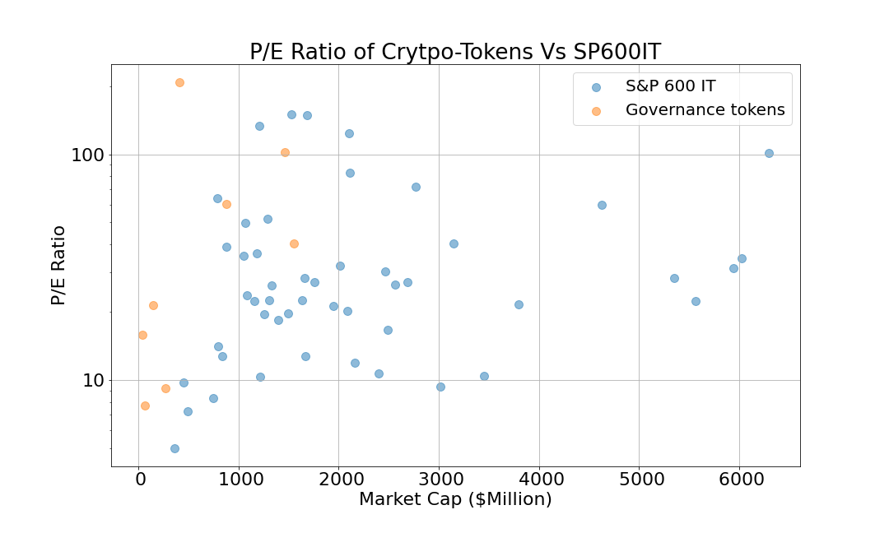

*Fig.2: P/E Ratio and Market Capitalization: SP600 IT Stocks vs Crypto Tokens*

# **Discounted Cash Flow Approach**

The discounted cash flow (DCF) approach offers a comprehensive valuation method, encompassing various factors such as the inherent risk associated with an asset, the growth rate of the cash flows it generates, and how these future cash flows are discounted to their present value. In simple terms, it posits that the fair value of an asset is equivalent to the risk-adjusted present value of all expected future cash flows, along with the value of cash holdings.

Among the DCF methodologies, one of the most widely employed is the Gordon growth model, which assumes a constant cash flow growth rate.[4] Consequently, we can determine the fundamental value of a crypto-token by estimating three key factors: the growth rate, the discount rate, and the current holdings within the protocol's treasury. Among these variables, the growth rate holds particular significance, although it's also the most challenging to pinpoint accurately.

A top-down approach that involves assessing macroeconomic trends, analyzing crypto-specific factors, and finally, formulating opinions on individual tokens is commonly used. However, it's essential to acknowledge the risk of overfitting when adopting such an approach. Instead, acknowledging the uncertainties tied to inflation and interest rates, the volatility inherent in crypto asset prices, and the ever-evolving regulatory landscape, we opt for a pragmatic approach. We establish a 9% nominal constant growth rate as the baseline for all tokens in the foreseeable future. While admittedly imperfect and somewhat arbitrary, considering an approximate 3% inflation rate over the next decade, a real growth rate for crypto tokens at 6% only slightly exceeds the broader economy growth rate, which we consider to be realistic for such a potentially-disruptive technology.

Subsequently, adhering to the conventional capital asset pricing model (CAPM), we estimate the discount rate by evaluating the beta of each token. Figure 3 illustrates that beta values for these tokens range from 1.9 to 3.1. In practical terms, this indicates that the crypto-tokens in question carry between twice and thrice the risk associated with the broader market. This alignment is consistent with findings from other studies concerning cryptocurrencies like Bitcoin and Ethereum. Accordingly, the derived discount rates span from 12.6% to 18%.

| **Token** | **Beta** | **Discount Rate** |
| --- | --- | --- |
| LDO | 3.10 | 18.04% |
| CVX | 2.37 | 14.77% |
| AAVE | 2.27 | 14.29% |
| CRV | 2.17 | 13.87% |
| VELO | 2.17 | 13.85% |
| SUSHI | 2.09 | 13.49% |
| BSW | 1.94 | 12.82% |
| COMP | 1.88 | 12.56% |

*Fig. 3: Betas and discount rates of selected crypto tokens*

The last phase involves calculating the discounted cash flow (DCF) value of crypto-tokens. Employing the Gordon growth formula, the earlier derived discount rates, a 9% constant growth rate applied uniformly across all tokens, and considering the treasury holdings, Figure 4 presents a comparison between the DCF value of crypto-tokens and their existing market capitalizations. The analysis reveals that on average the DCF value closely aligns with the current market value of these tokens. This shows that the prices at which crypto tokens trade on cryptocurrency exchanges are influenced by fundamental factors that can be substantiated by the risk and growth assumptions employed in this analysis.

| **Token** | **Treasury ($Mil)** | **Earnings ($Mil)** | **Discount Rate** | **DCF Value ($Mil)** | **Market Cap ($Mil)** | **Ratio Marketcap/DCF** |
| --- | --- | --- | --- | --- | --- | --- |
| AAVE | $103.6 | $14.64 | 14.29% | $405.37 | $804.6 | 1.98 |
| COMP | $102.1 | $1.97 | 12.56% | $162.36 | $322.2 | 1.98 |
| LDO | $248.8 | $38.46 | 18.04% | $712.59 | $1,380.0 | 1.94 |
| CRV | [$54.00](https://tokenterminal.com/terminal/projects/curve) | $14.26 | 13.87% | $373.09 | $389.7 | 1.04 |
| SUSHI | $8.13 | $6.90 | 13.49% | $175.88 | $136.8 | 0.78 |
| CVX | $3.13 | $29.77 | 14.77% | $565.41 | $220.7 | 0.39 |
| BSW | [$0.09](https://tokenterminal.com/terminal/projects/biswap) | $2.69 | 12.82% | $76.78 | $28.7 | 0.37 |
| VELO | $0.55 | $8.31 | 13.85% | $187.44 | $22.5 | 0.12 |
|  |  |  |  |  |  |  |
|  |  |  |  |  | **Average** | **1.08** |

*Fig.4: DCF values of Selected Crypto Tokens*

# **Speculation or Fundamentals?**

Contrary to prevailing notions, neither the relative valuation approach nor the DCF method provides compelling evidence of the existence of bubbles in crypto-token markets. The former indicates that these markets are not significantly more expensive than small-cap tech stocks, while the latter suggests that their market capitalizations largely align with the ballpark figures implied by their fundamental factors. It's worth noting that some assumptions were taken in assessing profit margins and growth rates.

However, the long-standing debate is far from reaching a resolution. Speculation undoubtedly played a role in the lead-up to this point and is likely to persist in some crypto market areas, but fundamentals are gaining influence as broader participation steers once-niche markets toward greater rationality and efficiency. Presently, it's evident that crypto-tokens are not as unconventional as commonly presumed, at least not from a valuation perspective.

1. The tokens chosen for this analysis are Lido (LDO), Convex Finance (CVX), Curve (CRV), Aave (AAVE), Sushiswap (SUSHI), Velodrome Finance (VELO), Compound Finance (COMP),and Biswap (BSW).
2. The data and code to replicate all results of this article can be found at <https://github.com/cesare-fracassi/HBR-Speculation-Fundamentals>. All analysis is based on information available as of August 31, 2023. Market capitalization is derived from readily available data on token price and supply, obtained from CoinMarketCap. Additionally, data concerning protocol revenues and treasury is sourced from DeFiLlama, serving as the foundation for our earnings estimates.
3. Some DAOs do not have operating costs, relying on the voluntary participation of DAO members. Others have allocated a significant pre-mined share of tokens to core developers, who have an incentive to continue managing and updating the protocol. Still others pay salaries to core developers. For example, the operating budget for the Lido DAO is over $22m annually, including salaries and overheads for 96 contributors, and marketing/legal expenditures.
4. For this exercise, we use standard assumptions about the market risk premium (4.5%) and the 10-year treasury rate as of August 31, 2023 as a proxy of risk-free rate (4.09%).